**Data statistics**

Following are the R squared values for 10 countries for four attributes

Male Population, Female Population, Total Population and Population density

| Countries | Attribute’s R^2 data | | | |
| --- | --- | --- | --- | --- |
| PopMale | PopFemale | PopTotal | PopDensity |
| spain | 0.952 | 0.961 | 0.957 | 0.957 |
| Afghanistan | 0.797 | 0.797 | 0.797 | 0.797 |
| India | 0.993 | 0.994 | 0.993 | 0.993 |
| Turkey | 0.999 | 0.999 | 0.999 | 0.999 |
| Zimbabwe | 0.961 | 0.984 | 0.975 | 0.975 |
| UAE | 0.804 | 0.913 | 0.841 | 0.841 |
| Belgium | 0.958 | 0.965 | 0.964 | 0.963 |
| Cambodia | 0.847 | 0.905 | 0.879 | 0.876 |
| Denmark | 0.920 | 0.931 | 0.928 | 0.927 |
| Egypt | 0.989 | 0.991 | 0.990 | 0.990 |

| Country | Ranking of Attribute |
| --- | --- |
| spain | PopDensity = PopTotal > PopFemale > PopMale |
| Afghanistan | PopDensity = PopTotal = PopFemale = PopMale |
| India | PopFemale > PopDensity = PopTotal = PopMale |
| Turkey | PopDensity = PopTotal = PopFemale = PopMale |
| Zimbabwe | PopFemale > PopDensity = PopTotal > PopMale |
| UAE | PopFemale > PopDensity = PopTotal > PopMale |
| Belgium | PopFemale >PopTotal > PopDensity > PopMale |
| Cambodia | PopFemale > PopTotal > PopDensity > PopMale |
| Denmark | PopFemale > PopTotal > PopDensity > PopMale |
| Egypt | PopFemale > PopTotal = PopDensity > PopMale |

A good model is considered to have higher R-squared (R^2) according to <https://statisticsbyjim.com/regression/interpret-r-squared-regression/>

Based on the above ranking, We are selecting the Total Population as the attribute for making further predictions.

In this part, we will mathematically predict the names of possible countries having total populations in the range 5,000 to 15,000 in 2011 through seeing the data.

Using Excel to make regression and predict population for countries through Analysis ToolPak Add-In Method and procedure

1.

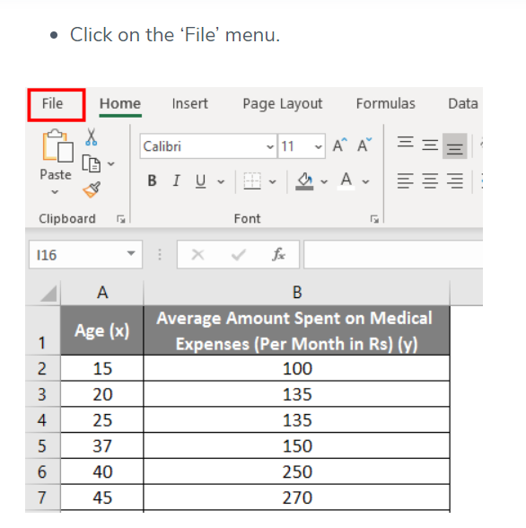

2.

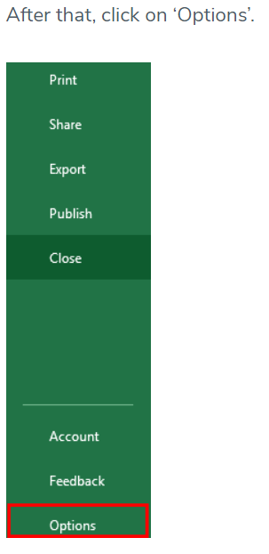

3.



4.

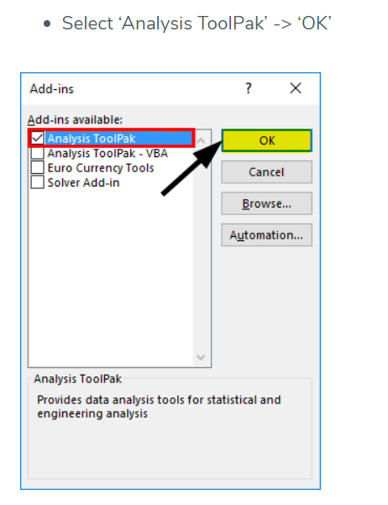

5.

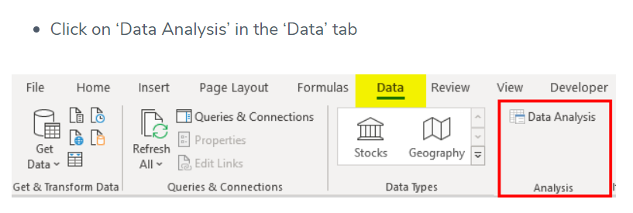

6.

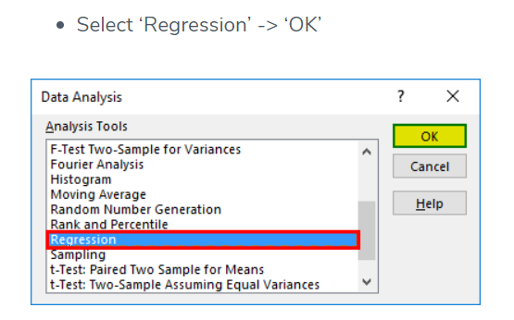

7.

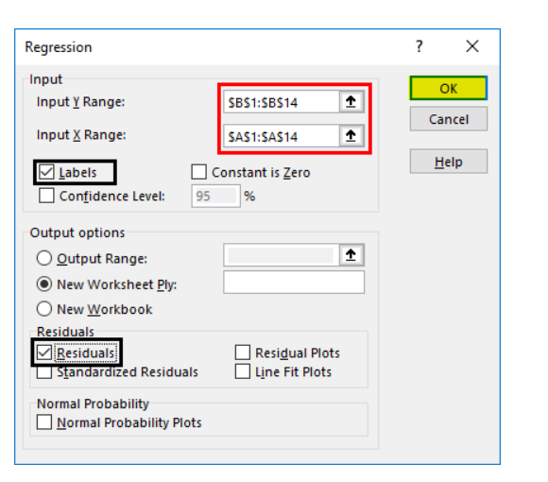

8.

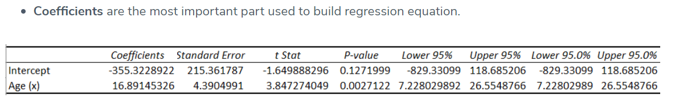

9.



| Country | Equation of line obtained | Total Population(y) for 2011(x) |
| --- | --- | --- |
| Afghanistan | y= 340.62x - 660807 | 24179.82 |
| Albania | y= 32.337x - 61466 | 3563.707 |
| Algeria | y = 533.47x - 1E+06 | 72808.17 |
| Angola | y = 339.1x - 661978 | 19952.1 |
| Argentina | y = 424.29x - 811824 | 41423.19 |
| Armenia | y = 21.086x - 38911 | 3492.946 |
| Aruba | y = 0.9916x - 1897.4 | 96.70 |
| Austria | y = 21.908x - 35744 | 8312.988 |
| Azerbaijan | y = 100.55x - 192945 | 9261.05 |
| Bahamas | y = 4.5862x - 8870.1 | 352.7482 |
| Bahrain | y = 16.703x - 32692 | 897.733 |
| Bangladesh | y = 2098x - 4E+06 | 219078 |
| Barbados | y = 1.0314x - 1791.2 | 282.9454 |
| Belarus | y = 31.795x - 53620 | 10319.745 |
| Belgium | y = 26.011x - 41669 | 10639.121 |
| Belize | y = 4.2501x - 8257.6 | 289.3511 |
| Benin | y = 130.7x - 254647 | 8190.7 |
| Bhutan | y = 9.7622x - 18925 | 706.7842 |
| Botswana | y = 32.05x - 62490 | 1962.55 |
| Brazil | y = 2603.7x - 5E+06 | 236040.7 |
| Bulgaria | y = -12.036x + 32314 | 8109.604 |
| Burundi | y = 105.58x - 204612 | 7709.38 |
| Cambodia | y = 168.34x - 325151 | 13380.74 |
| Cameroon | y = 296.85x - 578354 | 18611.35 |
| Canada | y = 312.65x - 594640 | 34099.15 |
| Caribbean | y = 424.04x - 810065 | 42679.44 |
| Chad | y = 160.96x - 313630 | 10060.56 |
| Chile | y = 181.88x - 348551 | 17209.68 |
| China | y = 15339x - 3E+07 | 846729 |
| Colombia | y = 599.79x - 1E+06 | 206177.69 |
| Comoros | y = 10.113x - 19693 | 644.243 |
| Congo | y = 60.395x - 117676 | 3778.345 |
| Costa Rica | y = 68.207x - 132541 | 4623.277 |
| Croatia | y = 2.7508x - 945.99 | 4585.8688 |
| Cuba | y = 82.406x - 153630 | 12088.466 |
| Cyprus | y = 10.697x - 20471 | 1040.667 |
| Czechia | y = 13.853x - 17327 | 10531.383 |
| Denmark | y = 15.154x - 24961 | 5513.694 |
| Djibouti | y = 17.463x - 34216 | 902.093 |
| Dominica | y = 0.0798x - 87.815 | 72.6628 |
| Ecuador | y=222.58x-432463 | 15145.38 |
| Egypt | y=1238x-2E+06 | 489618 |
| Eritrea | y=42.957x-83313 | 3073.527 |
| Ethiopia | y=1509.4x-3E+06 | 35403.4 |
| Fiji | y=8.2547x-15724 | 876.2017 |
| Finland | y=18.511x-31837 | 5388.621 |
| France | y=305.21x-550768 | 63009.31 |
| Gabon | y=27.125x-52910 | 1638.375 |
| Gambia | y=33.662x-65910 | 1784.282 |
| Georgia | y=-11. 569x+27641 | 4375.741 |
| Germany | y=112.43x-144214 | 81882.73 |
| Ghana | y=402.55x-784920 | 20108.05 |
| Greece | y=51.511x-92501 | 11087.621 |
| Greenland | y=0.3318x-608.59 | 58.6598 |
| Guadeloupe | y=2.2892x-4188.8 | 414.7812 |
| Guatemala | y=225.79x-439453 | 14610.69 |
| Guinea | y=154.95x-301408 | 10196.45 |
| Haiti | y=130.91x-253298 | 9962.01 |
| Honduras | y=137.5x-268289 | 8223.5 |
| Hungary | y=-10. 402x+30954 | 10035.578 |
| Iceland | y=2.7541x-5222.9 | 316 |
| India | y=16573x-3E+07 | 3328303 |
| Indonesia | y=3162.2x-6E+06 | 359184 |
| Iraq | y=524.55x-1E+06 | 54870 |
| Ireland | y=35.785x-67562 | 4401 |
| Israel | y=110.72x-215409 | 7249 |
| Italy | y=149.16x-240305 | 59655 |
| Japan | y=567.98x-1E+06 | 142207 |
| Kazakhstan | y=94.938x-173900 | 17020 |
| Kenya | y=676x-1321864 | 37572 |
| Kuwait | y=58.216x-113986 | 3086 |
| Kyrgyzstan | y=65.727x-126541 | 5635 |
| Latin America and the Caribbean | y=7721x-1.5E+07 | 526931 |
| Lebanon | y=57x-111196 | 3431 |
| Liberia | y=85x-88900 | 82035 |
| Libya | y=104x-204013 | 5131 |
| Liechtenstein | y=0.4x-752 | 52 |
| Lithuania | y=12x-18860 | 5272 |
| Luxembourg | y=4x-5913 | 2128 |
| Malawi | y=217x-424149 | 12238 |
| Malaysia | y=408x-793790 | 26698 |
| Maldives | y=5.5x-10740 | 320 |
| Mali | y=174x-337280 | 12632 |
| Malta | y=2.3x-4131 | 494 |
| Martinique | y=2.2x-3948 | 476 |
| Mauritania | y=51x-98359 | 4202 |
| Mauritius | y=12x-22267 | 1865 |
| Mayotte | y=4x-7343 | 701 |
| Mexico | y=1562x-3025602 | 115580 |
| Micronesia | y=7.5x-14476 | 606 |
| Mongolia | y=37x-71491 | 2916 |
| Morocco | y=417x-806937 | 31650 |
| Mozambique | y=293x-569992 | 19231 |
| Myanmar | y=628x-1211127 | 51781 |
| Namibia | y=31x-60780 | 1561 |
| Nepal | y=374x-724896 | 27218 |
| Netherlands | y=100x-185546 | 15554 |
| New Caledonia | y=3.6x-6873 | 366 |
| New Zealand | y=36x-68126 | 4270 |
| Nicaragua | y=85x-166543 | 4392 |
| Niger | y=232x-454112 | 12440 |
| Nigeria | y=2192x-4264229 | 143883 |
| North Macedonia | y=11x-20450 | 1671 |
| Norway | y=22x-39300 | 4942 |
| Oceania | y=394x-757126 | 35208 |
| Oman | y=50x-98405 | 2145 |
| Pakistan | y=2732x-5324632 | 169420 |
| Panama | y=50x-96949 | 3604 |
| Papua New Guinea | y=100x-194306 | 6794 |
| Paraguay | y=92x-179125 | 5887 |
| Peru | y=413x-800571 | 29972 |
| Philippines | y=1383x-2688873 | 92340 |
| Poland | y=191x-344960 | 39141 |
| Polynesia | y=7x-13708 | 369 |
| Portugal | y=43x-76218 | 10255 |
| Puerto Rico | y=30x-58107 | 2223 |
| Qatar | y=20.5x-40393 | 832 |
| Romania | y=52x-82170 | 22558 |
| Rwanda | y=134x-261035 | 8439 |
| Saint Vincent and the Grenadines | y=0.57x-1039 | 107 |
| Samoa | y=1.2x-2243 | 170 |
| Sao Tome and Principe | y=2.31x-4483 | 162 |
| Saudi Arabia | y=493x-966407 | 25016 |
| Senegal | y=186x-362322 | 11724 |
| Serbia | y=41x-72940 | 9511 |
| Seychelles | y=0.97x-1872 | 78 |
| Sierra Leone | y=73x-141217 | 5586 |
| Singapore | y=62x-121635 | 3047 |
| Slovakia | y=26x-48510 | 3776 |
| Slovenia | y=10x-18236 | 1874 |
| South Africa | y=736x-1429562 | 50534 |
| Spain | y=268x-495462 | 43486 |
| Sri Lanka | y=212x-405749 | 20583 |
| State of Palestine | y=62x-122825 | 1857 |
| Sudan | y=561x-1095361 | 32810 |
| Suriname | y=4x-7741 | 303 |
| Sweden | y=31x-54012 | 8329 |
| Switzerland | y=38x-69151 | 7267 |
| Tajikistan | y=110x-214416 | 6794 |
| Thailand | y=847x-1631388 | 71929 |
| Togo | y=95x-186904 | 4141 |
| Tonga | y=0.58x-1077 | 89 |
| Tunisia | y=147x-285339 | 10278 |
| Turkey | y=932x-1800931 | 73321 |
| Turkmenistan | y=74x-144632 | 4182 |
| Uganda | y=488x-954321 | 27047 |
| Ukraine | y=58x-67035 | 49603 |
| United Arab Emirates | y=111x-219954 | 3267 |
| United Kingdom | y=139x-220826 | 58703 |
| United States of America | y=2382x-4485136 | 305066 |
| Uruguay | y=16x-30052 | 2124 |
| Uzbekistan | y=416x-808636 | 27940 |
| Vanuatu | y=3.36x-6540 | 216 |
| Viet Nam | y=1187x-2295099 | 91958 |
| Yemen | y=368x-720724 | 19324 |
| Zambia | y=207x-405542 | 10735 |
| Zimbabwe | y=207x-402744 | 13533 |

The Countries having population between 5000 to 15000 in 2011 are Algeria, Austria, Azerbaijan, Belarus, Belgium, Benin, Bulgaria, Burundi, Cambodia, Chad, Cuba, Czechia, Denmark, Finland, Guatemala, Guinea, Haiti, Honduras, Hungary, Israel, Kyrgyzstan, Libya, Lithuania, Malawi, Mali, Niger, Papua New Guinea, Paraguay, Portugal, Rwanda, Senegal, Serbia, Sierra Leone, Sweden, Switzerland, Tajikistan, Tunisia, Zambia and Zimbabwe.